

**Digital Image Processing (CSE-438)**

**Sec:03**

**Lab: 03**

**Submitted to:**

Md. Asif Khan Rifat

Lecturer  
Department of Computer Science & Engineering

East West University

**Submitted by:**

Prinom Mojumder

2021-2-60-098

1. Apply salt and pepper noise to the following image and remove the noise using min and

max filtering technique. Show input and output side by side.

Code:

img = imread("Picture1.jpg");

if size(img,3) == 3

img = rgb2gray(img);

end

noisy_img = imnoise(img, 'salt & pepper', 0.02);

se = ones(3,3);

min_filtered_img = ordfilt2(noisy_img, 1, se);

max_filtered_img = ordfilt2(noisy_img, 9, se);

figure;

subplot(2,2,1), imshow(img), title('Original Image');

subplot(2,2,2), imshow(noisy_img), title('Noisy Image (Salt & Pepper)');

subplot(2,2,3), imshow(min_filtered_img), title('Min Filtered Image');

subplot(2,2,4), imshow(max_filtered_img), title('Max Filtered Image');

Output:

1. Apply Gaussian noise to the following image and remove the noise using Gaussian

filtering. Show input and output side by side.

Code:

img = imread('Picture2.jpg');

if size(img,3) == 3

img = rgb2gray(img);

end

noisy_img = imnoise(img, 'gaussian', 0, 0.01);

gaussian_filter = fspecial('gaussian', [5 5], 1);

filtered_img = imfilter(noisy_img, gaussian_filter, 'same');

figure;

subplot(1,3,1), imshow(img), title('Original Image');

subplot(1,3,2), imshow(noisy_img), title('Gaussian Noisy Image');

subplot(1,3,3), imshow(filtered_img), title('Denoised Image (Gaussian Filter)');

Output:

1. Apply any noise to the following image and restore it using:

a) Box filtering

b) Average filtering

c) Median filtering

Show input and output side by side. Also show the comparison between the 3 techniques.

Mention which method works better than others.

Code:

img = imread('Picture3.jpg');

if size(img,3) == 3

img = rgb2gray(img);

end

noisy_img = imnoise(img, 'salt & pepper', 0.02);

box_filter = fspecial('average', [3 3]);

box_filtered_img = imfilter(noisy_img, box_filter, 'same');

average_filter = fspecial('average', [5 5]);

average_filtered_img = imfilter(noisy_img, average_filter, 'same');

median_filtered_img = medfilt2(noisy_img, [3 3]);

figure;

subplot(2,3,1), imshow(img), title('Original Image');

subplot(2,3,2), imshow(noisy_img), title('Image with Noise');

subplot(2,3,3), imshow(box_filtered_img), title('Image with Box Filtering');

subplot(2,3,4), imshow(average_filtered_img), title('Image with Average Filtering');

subplot(2,3,6), imshow(median_filtered_img), title('Image with Median Filtering');

Output:

1. Adjust the histogram of the following image to match the reference image using histogram matching. Show the histogram of original, reference, and output images.

Code:

% a) Read and show the image

img = imread('Picture4.jpg');

figure;

imshow(img);

title('Loaded Image');

% b) Show the matrix form of the image

disp('Matrix form of the image:');

disp(img);

% c) Show pixel information by hovering the cursor

impixelinfo;

% d) Find the value of the pixel (10, 78) - handles RGB now!

x = 10;

y = 78;

pixel_value = img(x, y, :);

disp(['Pixel value at (10, 78): R=', num2str(pixel_value(1)), ...

', G=', num2str(pixel_value(2)), ', B=', num2str(pixel_value(3))]);

% e) Show the size of the image

[height, width, channels] = size(img);

disp(['Image size: ', num2str(width), 'x', num2str(height), ', Channels: ', num2str(channels)]);

% f) Show all the information of the image

disp('Full image details:');

disp(['Dimensions: ', mat2str(size(img))]);

disp(['Data type: ', class(img)]);

disp(['Number of pixels: ', num2str(numel(img))]);

Output: (a,c)

Output: (b,d,e,f)

1. Change the contrast of the image using histogram equalization. Show the histogram of both input and output images.

Code:

% Read the images

indexed_img_path = 'C:\Users\Students\Downloads\Lab 3\Picture5_3.tif';

gray_img_path = 'C:\Users\Students\Downloads\Lab 3\Picture5_2.jpg';

rgb_img_path = 'C:\Users\Students\Downloads\Lab 3\Picture5_1.jpg';

% Read RGB and Grayscale Images

rgb_img = imread(rgb_img_path);

gray_img = imread(gray_img_path);

% Check if grayscale image is already single-channel

if size(gray_img, 3) == 3

gray_img = rgb2gray(gray_img);

end

% Read Indexed Image & Check if It Has a Colormap

[indexed_img, map] = imread(indexed_img_path);

if isempty(map)

indexed_gray = gray_img; % No colormap, assume grayscale

indexed_rgb = rgb_img; % Assume already RGB

else

indexed_gray = ind2gray(indexed_img, map);

indexed_rgb = ind2rgb(indexed_img, map);

end

% Convert RGB to Grayscale

rgb_to_gray = rgb2gray(rgb_img);

% Convert Grayscale to Binary

binary_img = imbinarize(gray_img);

% Invert Binary Image

inverted_binary = imcomplement(binary_img);

% Histogram of Grayscale Image

figure, imhist(gray_img), title('Histogram of Grayscale Image');

% Invert RGB Image

inverted_rgb = imcomplement(im2uint8(rgb_img)); % Convert to uint8 to avoid issues

% Blur RGB Image

blurred_rgb = imgaussfilt(rgb_img, 2);

% Display results

figure;

subplot(3,3,1), imshow(rgb_img), title('RGB Image');

subplot(3,3,2), imshow(gray_img), title('Grayscale Image');

subplot(3,3,3), imshow(indexed_rgb), title('Indexed Image (Converted to RGB)');

subplot(3,3,4), imshow(rgb_to_gray), title('RGB to Grayscale');

subplot(3,3,5), imshow(indexed_gray), title('Indexed to Grayscale');

subplot(3,3,6), imshow(binary_img), title('Binary Image');

subplot(3,3,7), imshow(inverted_binary), title('Inverted Binary');

subplot(3,3,8), imshow(inverted_rgb), title('Inverted RGB');

subplot(3,3,9), imshow(blurred_rgb), title('Blurred RGB');

Output: (a,b,c,d,e,f,h,i)

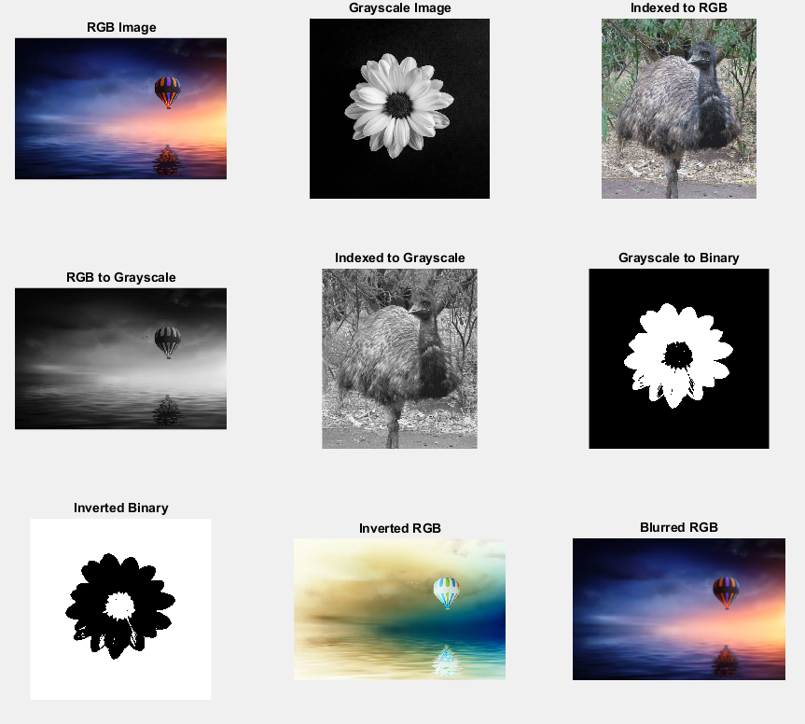

Output: (g)

